Tulse Hill Forum

CONSTITUTION
(as adopted at the AGM held on 26 June 2012, and amended by Special Resolutions approved at the AGM held on 26 June 2013 and EGM held on 26 November 2015)

- NAME

The legal name of the organisation shall be TULSE HILL FORUM (the Forum).

- DEFINITIONS

‘Tulse Hill’ refers to an area covering part of London postal districts SW2 and SE27, as defined by the Forum following consultation with the local community at Lambeth Country Show, Brockwell Park, July 2011. The ‘Tulse Hill area’ is hatched red on the plan appended at Annex 2 of this Constitution. ‘Tulse Hill area’ represents the area of benefit for the Tulse Hill Forum and includes the Tulse Hill electoral ward (as at 1.1.2012) and parts of other electoral wards in LB Lambeth. The area will be reviewed on a regular basis by the Forum in consultation with the local community and updated as necessary. There is a slightly different area of operation for neighbourhood planning purposes.

- OBJECTIVES

To give a voice to the people of Tulse Hill and to reflect their aspirations and concerns. To promote Tulse Hill and, in collaboration with the Borough of Lambeth and with other relevant organisations and individuals, work to develop, sustain and improve the area’s community, economy, environment and the quality of life and amenity for its residents, businesses and visitors.

- MEMBERSHIP

Membership of the Forum shall be open to any individual resident in the area as defined in Clause 1, or to any representative of a business or organisation located in the area, and who is interested in furthering the objectives of the Forum. All members must abide by the Code of Conduct for Tulse Hill Forum Members at Annex 1 of this Constitution. Membership will be effective on acceptance by the Forum committee of a completed membership application form. The Forum committee may only refuse an application for membership if, acting reasonably and properly, they consider it to be in the best interests of the Forum to refuse the application. The Committee must inform the applicant in writing of the reasons for the refusal within 21 days of the decision. The Committee must consider any written representations made by the applicant about the decision, and respond to those in writing, but ultimately the committee’s decision is final.

A membership list must be maintained and regularly reviewed, and any information held by the Forum on members must be in compliance with the Data Protection Act.

- EQUALITY OF OPPORTUNITY

  - The Forum will ensure it complies with the law in the United Kingdom and in particular the Equality Act 2010 and promote equality of opportunity for all individuals to participate in its work. The Forum will work to be representative of all groups in the community, especially hard to reach groups. The Forum will treat people from different groups fairly and equally.

- MEETINGS

- Forum AGMs and public meetings shall be open to anyone to attend. However, only Forum members can vote at such meetings.
- An Annual General Meeting (AGM) shall be held in or about May of each year to receive the Forum Committee's report and accounts and to elect Officers and Committee. The same shall be held not more than fifteen months after the holding of the last preceding Annual General Meeting.
- The Committee shall decide when other public meetings of the Forum shall be held. However, there will be a general aim of holding at least three public meetings each year in addition to the AGM.
- At least 21 days notice of the AGM and public meetings, including business to be discussed, shall be given to Forum members.
- A quorum for a general or public meeting of the Forum where a vote is taken shall be 10 eligible Forum members.
- An Extraordinary General Meeting (EGM) shall be convened at any time by the Chair on behalf of the Committee, or on written request for such a meeting signed by at least 10 members and specifying the business to be transacted. The Committee must convene the EGM within 35 days of receipt of a valid written request.
- Forum members shall be entitled to vote at AGM, EGM or public meetings. Voting decisions at an AGM, EGM or public meeting shall be made by simple majority of Forum members, with the Chair holding the casting vote (except for constitutional amendments as outlined in paragraph 11)
- Members may cast only one vote in any Forum vote. Any member attending in a personal and institutional capacity cannot cast multiple votes.
- Where a motion is to be put to a general or public meeting of the Forum, copies of that motion shall be sent to members at least 21 days before that meeting.
- Motions submitted at general or public meetings must be proposed and seconded by Forum members.

- OFFICERS

- The Officers of the Forum shall be: Chair, Vice Chair, Secretary and Treasurer.
- Nominations for electing Officers, supported by a seconder and with the prior consent of the nominee, shall be submitted to the Secretary in writing at least 7 days before the AGM.
- Nominees for election as Officers shall declare at the AGM at which their election is to be considered any financial or professional interest likely to be of concern to the Forum.
- Officers shall relinquish their office every year and shall be eligible for nomination at the AGM.

- FORUM COMMITTEE

- The Committee shall comprise the 4 Officers of the Forum, plus up to 11 additional Committee members. The Committee shall not exceed 15 Committee members. All committee members are automatically members of the Forum.
- The Committee shall be responsible for managing and administering the Forum.
- Role descriptions for all Committee members are available in a separate document which is reviewed regularly by the Committee.
- From time to time, in order to expedite decision-making, the Officers of the Committee, comprising the Chair, Vice Chair, Secretary and Treasurer, shall meet as an Executive Committee, and proceedings of such meetings will be recorded and reported to the next full Committee meeting.
- The Committee shall hold at least four Committee meetings each year. At least 7 days notice of Committee meetings shall be given to Committee members, including business to be discussed.
- All Committee meetings shall be minuted, minutes circulated to Committee members and be available to Forum members.
- Nominations for Committee members shall be made in writing to the Secretary at least 7 days before the AGM. Each individual member shall stand down before the AGM, but may seek re-nomination.
- The Committee may fill any vacancies that may arise amongst its membership during the year. Any such appointment will continue until the next AGM.
- All Committee members shall have the right to vote.
- At committee meetings a quorum shall comprise 5 members, or a third, (whichever is greater). In the event of a quorum not being achieved for any meeting, the meeting may continue, but any decisions made must be ratified at the next committee meeting at which a quorum is in attendance.
- The Chair shall not have a vote, except that in the event of an equality of votes cast at a Committee meeting, the Chair shall have a casting vote.
- Where it would help further its objectives, the Committee may seek the Forum’s membership of other organisations and nominate individual members to represent the Forum in such organisations.
- Ward councillors from any of the political parties who have councillors elected to represent the Tulse Hill ward and other wards included in ‘Tulse Hill area’ are welcome to attend committee meetings as observers and take part in discussions but will not have the right to vote.
- All committee members are expected to attend committee meetings. If a member is unable to attend a meeting, apologies should be made to the Secretary. If any member is absent from more than 3 consecutive meetings, without reasonable cause, the Committee has the power to remove that committee member. However, the committee member has the right to appeal against any such decision, and any appeals and responses should be in writing. The Committee’s decision is final.

- SUB-COMMITTEES

The Committee may set up sub-committees and working groups as it deems necessary. Each sub-committee or working group must include at least one member of the main Forum committee, and all actions and proceedings of sub-committees shall be reported to and be approved by the Forum Committee at the earliest possible opportunity. Forum Officers, who shall have the right to attend Sub-Committee meetings ex-officio, shall be advised in advance of the dates, venues and agendas of all such meetings. Members of the Committee may be members of any sub-committee. Membership of a sub-committee shall be no bar to appointment to the Forum Committee. Sub-committees shall be subordinate to and may be regulated or dissolved by the Forum Committee.

- DECLARATIONS OF INTEREST

Every member of the Forum Committee or any sub-committee who is present at any meeting and who has any direct, indirect or potential financial, professional or political interest in any item discussed shall declare such interest. He/she shall not discuss any such item (except by invitation of the Chair) or vote thereon. All declarations of interest will be recorded in a Register of Interests maintained by the Secretary, and regularly reviewed.

- FUNDING AND EXPENDITURE

- The Forum Committee may raise funds and invite and receive grants, subscriptions and donations
- The Committee may open and operate bank accounts in the name of the Forum.
- The Committee shall, out of the Forum’s funds, pay all properly authorised administrative and management expenses. After paying these expenses, the remaining funds shall be applied by the Committee to further the Forum’s objectives.
- No expenditure over £250 shall be made or financial commitment entered into without the prior agreement of the Committee. For payments of £250 or under, these shall be authorised by at least 2 of the 4 Officers, one of whom shall be the Treasurer. Written records of such authority will be kept.
- The Forum Treasurer shall keep proper accounts, monitor income and expenditure, reporting as required to the Committee and presenting annual accounts to the Forum AGM.
- The Forum’s financial year shall run from 1 April to 31 March.
- The Forum Treasurer shall prepare annual accounts and arrange for these to be independently audited or examined, as required, and presented to the Forum AGM.
- Up to three members of the Committee shall be empowered to sign cheques drawn on the Forum’s bank account(s). Signatures of two of these members shall be required on each cheque drawn.

- AMENDMENTS

This Constitution may be altered by a written resolution passed by not less that two thirds of the members present and voting at a public meeting. The notice of the public meeting must include notice of the resolution, setting out the terms of the alteration proposed. At least 21 days notice of the meeting and the resolution must be given.

- NOTICES

Any notice required under these rules shall be deemed to be given if left at, or sent by prepaid post, by Email or by text message to the address of that member last notified to the Secretary.

- WINDING UP

The Forum may be dissolved by a two thirds majority of eligible members voting at an AGM or a General Meeting. If a motion for the Forum’s dissolution is to be proposed, specific reference shall be made to this motion when giving notice of the meeting. In the event of dissolution, the Forum’s available funds shall be transferred to one or more organisations having similar objectives, to be chosen by the Committee. However, any unspent or uncommitted funds given for a specific purpose shall, wherever practicable, be returned to the donor. On dissolution the Forum’s minute books and other records shall be deposited with the Lambeth Archives.

CERTIFIED AS A TRUE COPY OF THE ORIGINAL

Signed: Dated:

____________________________
Chair
Tulse Hill Forum
Annex 1: Tulse Hill Forum: Code of Conduct of Forum Members
  - All Tulse Hill Forum members must conduct themselves in a way that does not cause offence to others or bring the Forum into disrepute.
  - Members must treat others with respect and must avoid racist, sexist or other derogatory remarks or actions.
  - Members must allow others to speak without interruption or other inappropriate behaviour.
  - Members must be sensitive to the needs of those who may not be used to speaking in public or whose first language is not English.

5. Members who feel that this Code of Conduct has been breached should raise the matter with the Chair at the earliest opportunity, for the Chair to take appropriate action.

Annex 2: Tulse Hill area

The area hatched red on the attached plan represents the area of benefit for the Tulse Hill Forum as at 29th May 2012

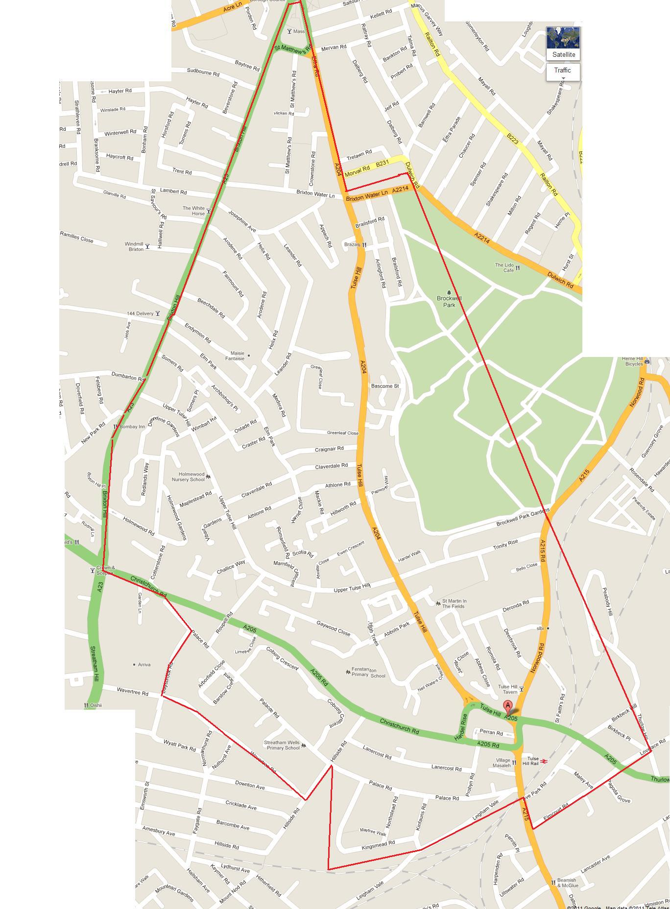

Treasurer and signatory

JENNYFER MCLEAN

57 Athlone Road Tulse Hill SW2 2DU

jmch74@yahoo.com

Chair and Signatory

Erica Tate

109c Upper Tulse Hill Sw22RD

Ericatateuk@yahoo.co.uk

Bank Statements

