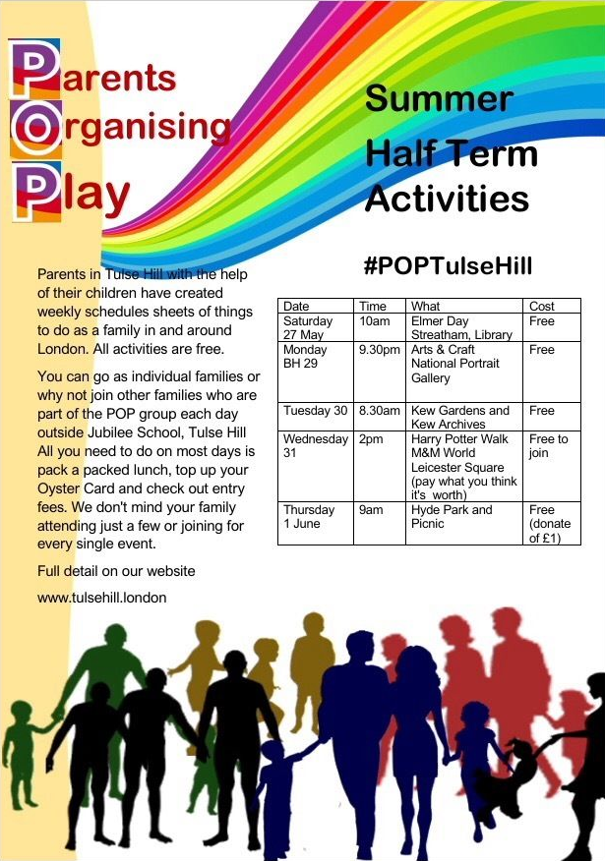
OUTING ASSISTANT VOLUNTEER ROLE.
Assist families who live in Tulse Hill on outings.
Meeting Families at set off point
Hand out relevant information to the families about trip from the set off point, and promote the POP project to those families that live in relevant areas.
- Assist attendees to fill in signing in sheet
- Occasionally assisting the Families on and during the outing.
- Engaging with the Families during the outing and helping the families get the most out of their time out with the POP group.

Outings usually occurs Term holidays, one day a month In term times (usually the 4th Saturday of each month). Minimum of 1 hour if not attend outing but just linking at set off point. 4-6 hour if attending full outing.
QUALIFICATIONS:
Minimum age: 18 years. Enjoys working with families willingness to learn, positive outgoing attitude, patience, and good communication skills.
DESIRED REQUIREMENTS BUT NOT ESSENTIAL
Parents of a family group living in Tulse Hill.
ROLE IS SUITABLE FOR:
Adult over 18
ADDITIONAL INFORMATION:
Volunteers will receive: Free admission to local attractions/events, a confirmation letter of volunteering after completing 30 volunteer hours, invitation to an annual Volunteer events, and the chance to increase the quality of life for a member of your community.
#POPTulseHill

